***LSS highlight at Interpack their labelling solutions for small batch packaging helping speed parenteral products to market.***

As the demand for self-administered parenterals grows, so does the need for small-batch packaging solutions to help speed them to market.

Pharma and biotech development is expanding at a tremendous rate following sustained growth of pharmaceutical-based health care around the world. To maintain health and deal with chronic disease, more people are self-administering parenteral prescriptions and taking over the counter (OTC) medications than ever before.

Although billions of doses will continue to be dispensed from basic packaging, millions more doses are being delivered to patients in new, more patient-centric ways, including single-unit dose delivery and specialized functional combinations that marry the drug with the delivery device or the patient to a personalized therapy.

Drug packaging has never been more functional or diverse, or more complex. For most drug manufacturers and packagers, complexity is surging, along with labelling requirements and the technical capabilities needed to accomplish successful drug delivery. How can pharma tackle the surging parenteral drug labelling complexity to come?

Clearly labelled and marked primary drug packaging and devices help clinicians and patients accurately administer treatments and simplify delivery, especially for injectable and infusible therapeutics.

Many of these combination devices have limited label real estate and challenging surface characteristics and are tough to label. These circumstances explain why parenteral labelling in particular is growing more integral, complex and technically challenging.

Designed to support customers working on everything from clinical trials to small batch production, LSS’s made to measure labelling solutions are fully adjustable based on customer requirements, and use a combination of labelling modules to form the base elements of their labelling units.

Lars Skole, managing director at LSS, said: “When it comes to labelling devices, precision is paramount. If a label is incorrectly positioned it may obscure important information on the injectable device or pre-filled syringe.

“Our device labelling products offer accuracy of up to 0.2mm and also carry out a comprehensive self-inspection of your devices, ensuring correct label placement in order to guarantee complete peace of mind.”

Our pharma device labelling units are installed with a fully validated and CFR21 Part 11 compliant vision inspection system with integrated user management and audit trail system. The labels are inspected after print, before application to the product. Non approved labels are rejected before applied onto the device. The device can be inspected before label application. After labelling the presence and position of the label at the device are inspected. Non approved devices are rejected. Only approved devices are allowed to leave the index wheel.

LSS’s solutions use a combination of standard labelling modules, designed to integrate with all types and shapes of pens and auto-injectors. The base labelling module can be combined with in-feed and outfeed modules, for both in-line production and for products in trays. The equipment can support cartridges, prefilled syringes and devices, with a capacity of up to 200 products per minute.

Lars continued: “LSS has been supplying the pharma industry for over 20 years and designs every solution with our customers in mind. We know that our customers require flexibility, so we create customised solutions for small batches and in-line handling.”

Images:

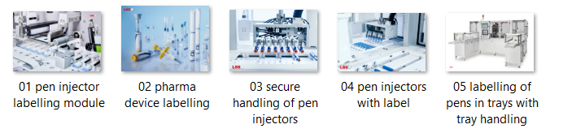

LSS owns the rights of all pictures and pictures must only be used in accordance with information about LSS. (© LSS)

**Scan for digital version and pictures**



**Short company profile of LSS**

With more than 45 years of experience engineering precision labelling systems, LSS has significant expertise in successfully delivering made to measure device and vial labelling solutions for the pharmaceutical and biotechnology industries and specialize in small batch packaging solutions.

In 2014 LSS was acquired by Possehl and is today member of the PID – Possehl Identification Solution group.

**Contact information:**

LSS - Labelling Systems Scandinavia

Normansvej 8

DK-8920 Randers NV

Denmark

**Contact person**

Ulla Laursen

Sales & Marketing

Phone: +45 8711 0826

E-mail: ul@lss-dk.com

<https://www.lss-dk.com/pharmaceutical-industry>